Media Contact:
Sarah Wynn Benton
BRAVE Public Relations
404.233.3993
sbenton@emailbrave.com
FOR IMMEDIATE RELEASE

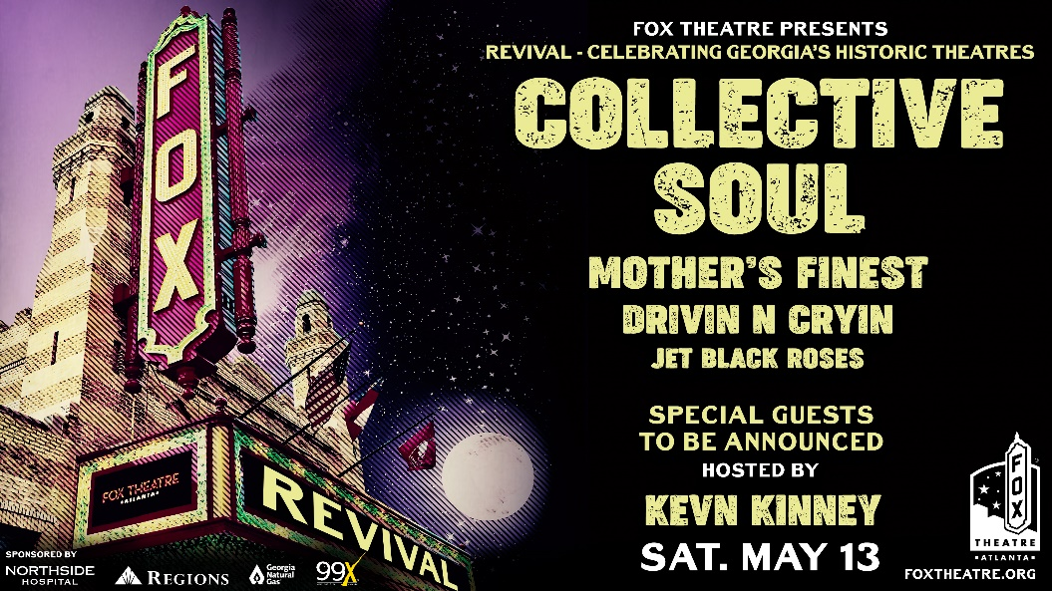

Fox Theatre Announces Revival, its Third Benefit Concert, Featuring Collective Soul, Mother’s Finest, Drivin N Cryin, and Jet Black Roses on May 13
Proceeds will support Georgia’s historic theatres and the Fox Theatre’s education programs

ATLANTA (Feb. 20, 2023) – The Fox Theatre is set to host a historic night on Saturday, May 13, as the theatre celebrates 15 years of preservation efforts through its outreach program the Fox Theatre Institute (FTI). Hosted again by Atlanta native and famed musician Kevn Kinney, the organization’s Revival benefit concert will raise money to preserve and restore Georgia’s historic theaters and expand its education arm through an auction. With performances by Collective Soul, Mother’s Finest, Drivin N Cryin, Jet Black Roses and other special guests, this unique musical event is inspired by the power of storytelling and the role theaters play in bringing communities together. Tickets for “Revival” go on pre-sale Thursday, February 23 at 10am and go on sale to the general public on Friday, February 24 at 10 am at foxtheatre.org.
“Championing historic theatres through preservation and operational support has been the priority of our work these past fifteen years,” said Fox Theatre Institute Director Leigh Burns. “The opportunity to have this outstanding fundraising opportunity for our historic Georgia theatres after navigating the effects of a pandemic is something we never anticipated when we last gathered in 2019. We look forward to celebrating the work of our fellow preservationists during our 2023 Revival Concert while raising awareness and funding for our educational programs.”

Participating band members recall their early days in the theatre and why its preservation is imperative for the community.

“When I was 14 years old, I went to see my first live show, and it just happened to be at the Fox Theatre in Atlanta,” said Dean Roland of Collective Soul. “That night I was overwhelmed with what I now know to be the historic energy of so many artists that had graced that stage. It put a spark in my soul that I treasure and still motivates me to this day. It’s essential that we do what we can to preserve these types of venues.”
Drivin N Cryin’s front man Kevn Kinney echoes the sentiment saying, “There is no substitute for a theater full of people from every walk of life laughing, thinking and crying together.” From the smell of the popcorn to sitting in the same seat his grandparents once did, Kinney recollects how strong the memories created in a theater can be.

“Art is the backbone of our society”, said Collective Soul’s Ed Roland. “From the beginning, historic theatres allowed those arts to be portrayed through plays, movies and music. It is so important that we do everything we can to preserve these meaningful buildings, so we can continue to spread joy and creativity that we will never forget.”
Echoing Roland’s sentiment, Collective Soul’s bassist, Will Turpin, states that “preserving our past is one of the most important things we can do as a society. The Fox Theatre and its historic moments belong amongst the most esteemed places in Atlanta history.”
All concert attendees will be invited to participate in a live “Fund-A-Mission” auction driven by Atlanta’s Your Rocktioneer from the Fox’s stage. This live component will help raise money for FTI’s educational arm, “Fox in a Box,” a program that directly benefits students throughout Georgia. “Fox in a Box” teaches students about the communal history of the Fox Theatre and challenges them to think about the importance of communities banding together to protect what is important to them. This auction includes notable items and experiences such as a private behind-the-scenes tour and dining experience at the Fox Theatre’s famed Marquee Club presented by Lexus, signed artist memorabilia like Joe Bonamassa’s guitar, and more.

“Revival’s” Fund-A-Mission sponsor and Official Bank of the Fox Theatre, Regions Bank, will generously match what the audience is able to raise in this interactive five-minute fundraiser. More details on how to participate in each of the auction activities are coming soon and fans are encouraged to check the event’s web page at foxtheatre.org for more information.

Tickets to “Revival” start at $40.50 (plus applicable fees) and are available for purchase at FoxTheatre.org or by calling 855-285-8499.

###
About the Fox Theatre Institute:
The Fox Theatre Institute (FTI) is a dynamic outreach program offering historic preservation expertise, consultation, and education to performing arts venues in Georgia and the region. Created by Atlanta’s Fox Theatre, an iconic attraction widely applauded for being a catalyst for positive change in the community, FTI pays it forward, helping other cultural institutions renew, reinvigorate, and restore artistic vitality in their backyards and beyond. Keeping environmental and economic impact top of mind, FTI offers the financial assistance, restoration support and operations mentoring needed to leverage scarce resources and stimulate local economies. Not only that, but it keeps the artistic pulse of beloved communities beating for decades to come. FTI was recently featured on NPR’s Marketplace for its substantial impact on historical theatre restoration and community building throughout Georgia and the Southeast. FTI has provided technical assistance in preservation, architecture, and nonprofit consulting in more than 50 communities while awarding over $2.7 million across Georgia. Click here for additional facts and statistics, and for more information, visit www.foxtheatreinstitute.org.
About the Fox Theatre:
The Fox Theatre is one of Atlanta's premier venues for live entertainment, welcoming more than 250 performances a year in its 4,665-seat theatre. From concerts to ballets, comedy, and movies, the historic venue attracts more than 500,000 visitors annually. The theatre also hosts over 100 annual private events like wedding receptions, trade shows, corporate meetings, and association functions in two fabulous ballrooms. The Fox’s premium Marquee Club presented by Lexus, is a 10,000 sq. ft, three-story luxury bar accessible to all Club Level ticket holders or annual members of the Fox Theatre. As a 501(c)(3) nonprofit arts organization, the Fox Theatre stands today as a fiercely protected landmark and a nationally acclaimed theatre. The Fox Theatre proudly acknowledges its partners for their generous support: Coca-Cola, Lexus, Georgian Terrace Hotel, Georgia Natural Gas, and Regions Bank. Tickets for all events are available at FoxTheatre.org, or toll-free at 855-285-8499. Stay connected by following the Fox Theatre on social via @theFoxTheatre on Instagram, Twitter, and Facebook.
Notable accolades 2022 IEBA Theatre of the Year; 2021 Billboard Magazine #1 Highest Grossing Theatre Worldwide (5,000 seats or less); 2021 Pollstar Magazine #2 Theatre Worldwide in Ticket Sales; 2021 Venues Now Magazine #2 Year-End Top Stops (2,001-5,000 seats); 2019 Venues Now #1 Top Stop of the Decade Award for Tickets Sold.

